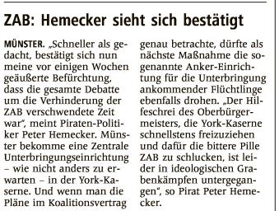

|  |  |  |  |  |  |  |  |  |  |  |  |  |  |  |  |
| --- | --- | --- | --- | --- | --- | --- | --- | --- | --- | --- | --- | --- | --- | --- | --- |
| https://epaper.wn.de/digiPaper/image/msh/picture/msh_Spacer.gif | |  |  | | --- | --- | | Quelle | | |  | | | Verlag | : Westfälische Nachrichten | | Publikation | : Münster | | Ausgabe | : Nr.66 | | Datum | : Montag, den 19. März 2018 | | Seite | : Nr.21 | |