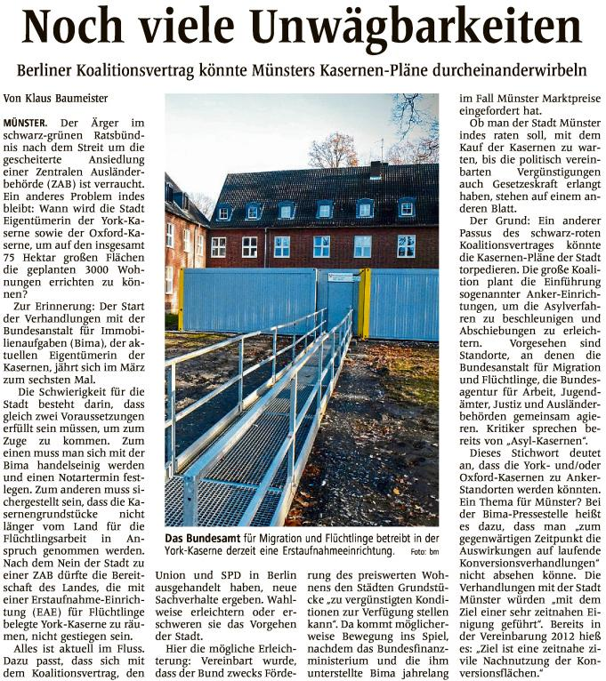

|  |  |  |  |  |  |  |  |  |  |  |  |  |  |  |  |
| --- | --- | --- | --- | --- | --- | --- | --- | --- | --- | --- | --- | --- | --- | --- | --- |
|  | |  |  | | --- | --- | | Quelle | | |  | | | Verlag | : Westfälische Nachrichten | | Publikation | : Münster | | Ausgabe | : Nr.41 | | Datum | : Samstag, den 17. Februar 2018 | | Seite | : Nr.19 | |