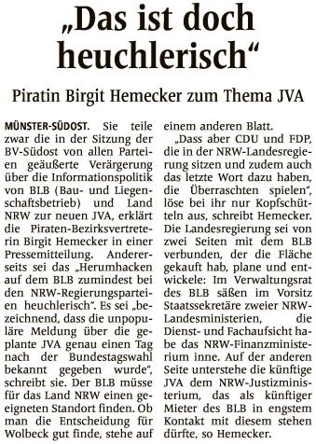

|  |  |  |  |  |  |  |  |  |  |  |  |  |  |  |  |
| --- | --- | --- | --- | --- | --- | --- | --- | --- | --- | --- | --- | --- | --- | --- | --- |
| https://epaper.wn.de/digiPaper/image/msh/picture/msh_Spacer.gif | |  |  | | --- | --- | | Quelle | | |  | | | Verlag | : Westfälische Nachrichten | | Publikation | : Münster-Hiltrup | | Ausgabe | : Nr.241 | | Datum | : Dienstag, den 17. Oktober 2017 | | Seite | : Nr.23 | |