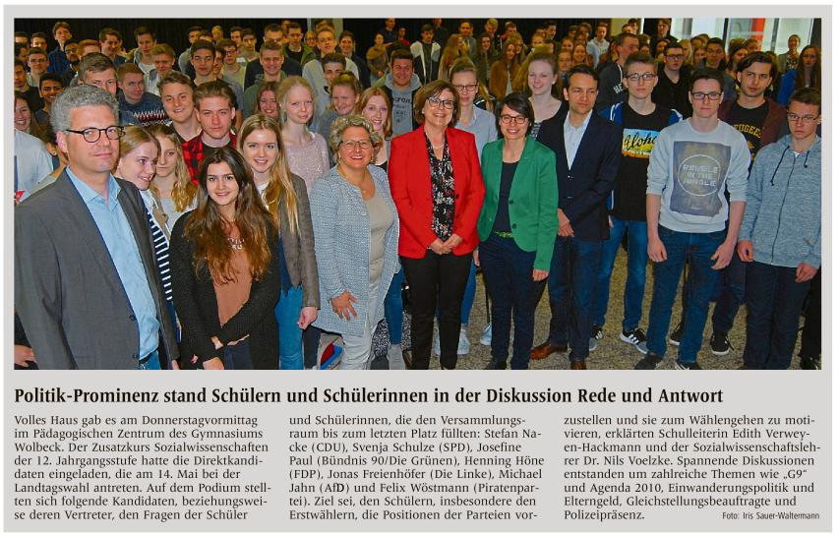

|  |  |  |  |  |  |  |  |  |  |  |  |  |  |  |  |
| --- | --- | --- | --- | --- | --- | --- | --- | --- | --- | --- | --- | --- | --- | --- | --- |
|  | |  |  | | --- | --- | | Quelle | | |  | | | Verlag | : Westfälische Nachrichten | | Publikation | : Münster-Hiltrup | | Ausgabe | : Nr.77, Seite 24 | | Datum | : Freitag, den 31. März 2017 | |  |  | |